explain this Sorting Example :
Setup:
- 10^7 records of 100 bytes = 10^9bytes file.
- Stored on a disk with 4Kbyte blocks, each holding 40 records + header
information.
- Entire file takes 250,000 blocks.
- 50 Mbyte available main memory = 12,800 blocks 1/20th of file.
- Task: Sort records of file by primary key field.

solution:
- Total number of records we can sort: (M/R) * ((M/B) –1) = M^2/ (R * B)
In our example: 6.71* 10^9 records

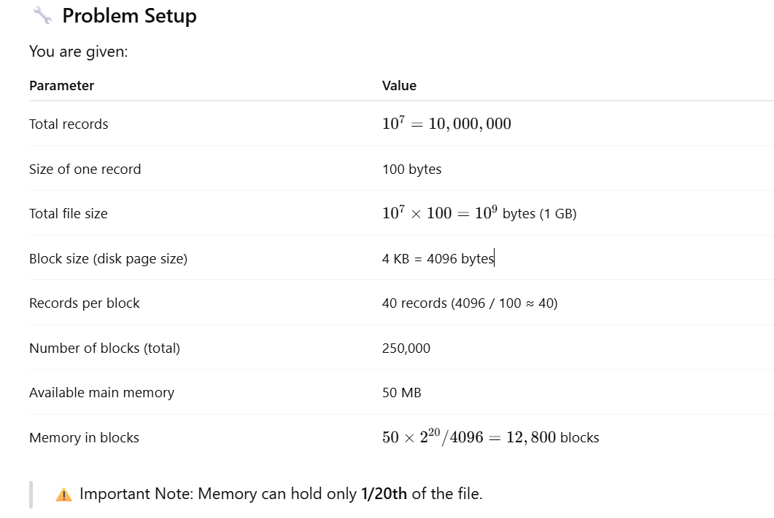
🎯 Goal: Sort the records by primary key using external sort
Since the file is too large to sort in memory, the DBMS must use external sorting, usually two-pass multiway merge sort.

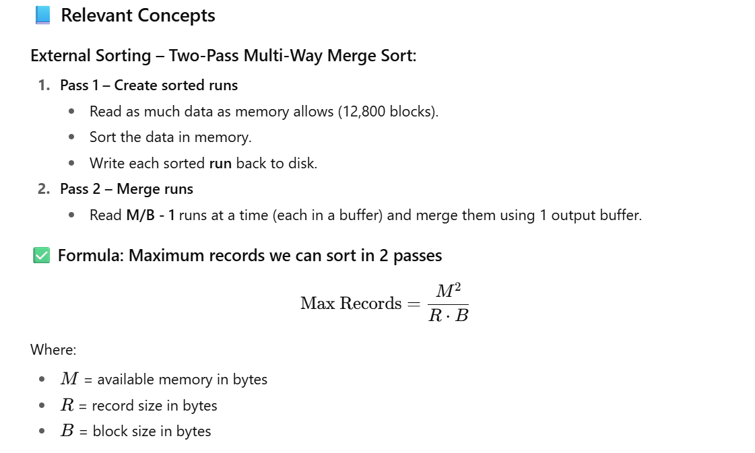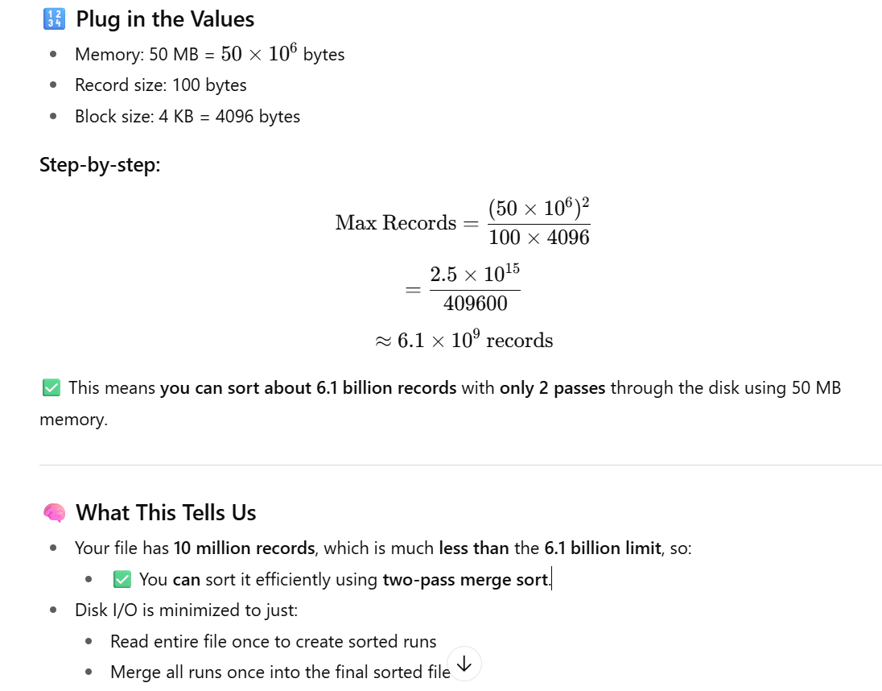

how we calculate both values Total blocks needed and Memory in blocks! step by step information provided:

📦 1. Total Number of Blocks (Disk Pages)
We are told:
- There are 107=10,000,00010^7 = 10,000,000 records
- Each record is 100 bytes
- Block (page) size is 4 KB = 4096 bytes
- Each block holds 40 records

✅ Step-by-step Calculation:
🧠 Explanation: Each 4KB block holds 40 records (4096 ÷ 100 ≈ 40), so to store 10 million records, you need 250,000 blocks.

🧠 2. Memory in Blocks
You are told:
- Available memory = 50 MB = 50×1024×1024 = 52,428,800
- Block size = 4 KB = 4096 bytes

✅ Step-by-step Calculation:
🧠 Explanation: Memory can hold 12,800 blocks at once, which is 1/20th of the entire file (250,000 blocks).

🔁 Final Result:
Metric | Value
Total records | 10,000,000
Records per block | 40
Total blocks needed | 250,000
Available memory | 50 MB
Memory in blocks | 12,800 blocks

Implementation of DBMS
Exercise Sheet 2
WS 2024 / 2025

- Suppose you use Two-Phase Multiway Merge Sort in the scenario described in the lecture slides.
Tell how many disk I/O's are needed for the sort if the following changes are applied:
a) The number of records of the file is tripled. Soln: 3,000,000
b) The size of blocks is doubled, to 16384 bytes. Soln: 250,000
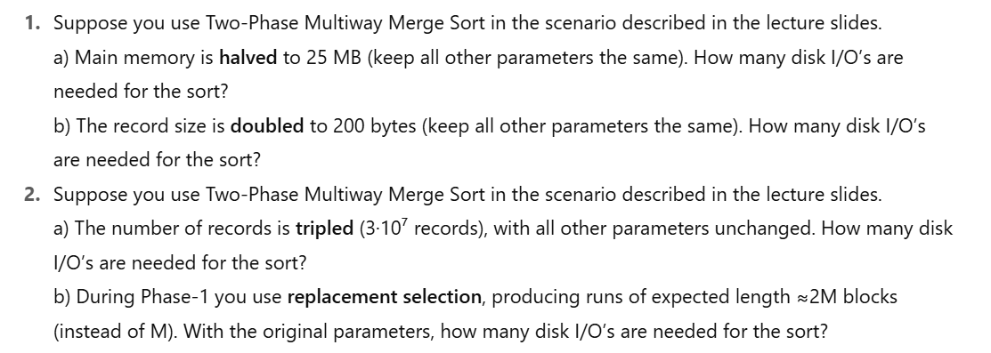

- Suppose we have a relation whose n tuples each require P bytes, and we have a machine whose main memory M and disk-block-size are just sufficient to sort the n tuples using Two-Phase Multiway Merge Sort. How would the maximum n change if we made one of the following modifications of parameters?
a) triple P = B.
b) triple S = R.
c) triple M.
- You want to use the Two-Phase Multiway Merge Sort (or its extension to a different number of phases as appropriate) to sort a file. The file consists of 256,740 records. Each block can contain 25 records. We have 15 main memory blocks available.
a) How many blocks do we need to store the file if each block is as full as possible?
b) How many phases do we need?
c) What is the required number of I/O's?
d) How many sorted sublists do we have after each phase?

Additional Questions for Two-Phase Multiway Merge Sort (2PMMS):

3a
You have a file containing 157,625 records. Each disk block can hold 25 records, and the available main memory can hold 15 blocks.
a) How many disk blocks are required to store the entire file if each block is as full as possible?
b) How many phases are required to sort this file?
c) What is the total number of I/O operations required to sort this file using 2PMMS?
d) How many sorted sublists will be generated after Phase 1?
Soln:
- 6305 Block
- 4 phases
- 50,440 I/Os
- 29 sorted sublist

3b
A dataset contains 231,040 records, with each block storing 40 records. Assume you have a main memory capable of holding 20 blocks.
a) Calculate the total number of disk blocks required to store the dataset.
b) How many phases will be required to sort this dataset using 2PMMS?
c) Determine the total I/O cost of sorting this dataset.
d) How many sorted sublists are generated in the first phase of sorting?

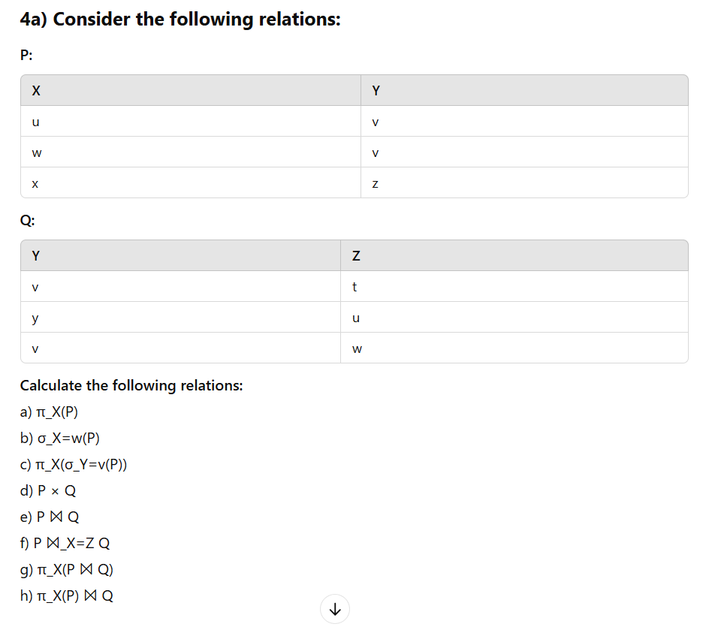
Improved and Complete Question:
Scenario:
You are using Two-Phase Multiway Merge Sort, a popular external sorting algorithm designed for datasets that cannot fit entirely into memory. This algorithm sorts data in two phases:
- Run Generation Phase:
  - Records are divided into smaller runs that fit into the available main memory and are sorted individually.
  - Each sorted run is written back to disk.
- Merge Phase:
  - The sorted runs are merged iteratively in multiple passes until the entire dataset is sorted.
  - Disk I/O operations play a crucial role in the performance of this algorithm, as data is read from and written to disk multiple times.
In this scenario:
- The file initially contains 6.71 × 10⁶ records.
- Each block can hold 20 records, and the block size is 4096 bytes.
- Each pass involves 4 I/O operations per block.

Question 1: Analyze the Effect of Changes in Records and Block Size
Determine the number of disk I/O operations required for sorting if the following modifications are applied:
a) The number of records in the file is doubled.
- Solution:
First, check whether two passes are still sufficient for sorting the increased number of records.
  - With the initial settings, 6.71 × 10⁶ records can be sorted in two passes.
  - Doubling the number of records requires twice the number of blocks. Since there are 4 I/O operations per block, doubling the blocks results in twice the number of I/O operations.
  - Total I/Os = 2,000,000 I/O operations.
b) The size of blocks is doubled to 8192 bytes.
- Solution:
Doubling the block size allows us to store twice the number of records per block, reducing the total number of blocks required.
  - Fewer blocks mean half the number of I/O operations compared to the original configuration.
  - Total I/Os = 500,000 I/O operations.
Note: Larger blocks increase the time for individual I/O operations, potentially impacting performance.

Key Learning Objectives Covered:
- Impact of Scaling Data Volume:
  - Understand how increasing the number of records affects sorting performance.
- Effect of Block Size on Efficiency:
  - Analyze how larger blocks reduce I/O operations but may increase latency per operation.
- Optimization of External Sorting Algorithms:
  - Explore trade-offs in external sorting techniques and optimize performance for large datasets.

Implementation of DBMS
Exercise Sheet 2 similar questions
WS 2024 / 2025

- Suppose you use Two-Phase Multiway Merge Sort in the scenario described in the lecture slides.
Tell how many disk I/O's are needed for the sort if the following changes are applied:
a) The number of records of the file is quadrupled.
b) The size of blocks is doubled, to 4096 bytes.
- Suppose we have a relation whose n tuples each require Q bytes, and we have a machine whose main memory M and disk-block-size are just sufficient to sort the n tuples using Two-Phase Multiway Merge Sort. How would the maximum n change if we made one of the following modifications of parameters?
a) Double Q.
b) Double B.
c) Double M.
- You want to use the Two-Phase Multiway Merge Sort (or its extension to a different number of phases as appropriate) to sort a file. The file consists of 85,620 records. Each block can contain 30 records. We have 12 main memory blocks available.
a) How many blocks do we need to store the file if each block is as full as possible?
b) How many phases do we need?
c) What is the required number of I/O's?
d) How many sorted sublists do we have after each phase?

Implementation of DBMS
Exercise Sheet 2
WS 2024 / 2025

1. Extended Two-Phase Multiway Merge Sort Questions
- Given Scenario:
You have a file with 1,200,000 records, and each block can store 50 records. Main memory can hold 500 blocks at a time. Assume Two-Phase Multiway Merge Sort is used.
Answer the following questions:
a) How many blocks are required to store the file initially?
b) How many runs will be created in the first phase?
c) What is the maximum number of blocks that can be merged in a single pass during the second phase?
d) How many total I/O operations are needed to sort the file?

- Memory and Parameters Change:
Suppose the following parameters are given for Two-Phase Multiway Merge Sort:
  - File size = 2,000,000 tuples, each requiring 400 bytes.
  - Disk block size = 8 KB (8192 bytes).
  - Available main memory = 128 MB (134,217,728 bytes).
Calculate the following:
a) How many tuples can fit into a single block?
b) How many blocks are required to store the entire file?
c) How would the number of disk I/O operations change if the memory size is doubled?
d) How many merge passes are needed to sort the file?

3. Modified Merge Parameters
Given a dataset consisting of 500,000 records:
- Each record is 100 bytes.
- Block size = 4 KB.
- Memory size allows for 50 blocks at a time.
Questions:
a) What is the total number of blocks required to store the records?
b) If only 40 blocks of memory are available for merging, how many merge passes would be required?
c) How many I/O operations are needed in total to sort the file?
d) What is the size of each sorted run after the first phase?

Implementation of DBMS
Exercise Sheet 2
WS 2024 / 2025
1. File Size and Block Calculations
You are tasked with sorting a file using Two-Phase Multiway Merge Sort. The file contains 1,000,000 records.
- Each record is 200 bytes.
- Disk block size = 4 KB.
- Memory can hold 100 blocks at a time.
Questions:
a) How many records can fit into a single block?
b) How many blocks are required to store the entire file?
c) How many initial runs will be created in the first phase?
d) How many merge passes are required to fully sort the file?

2. Changing Memory Parameters
Suppose a file with 2,500,000 records is being sorted using 2PMMS. Each block can store 40 records, and the main memory can hold 120 blocks at a time.
Questions:
a) How many blocks are needed to store the file initially?
b) If the number of memory blocks available is halved, how many merge passes would be required?
c) How does doubling the block size affect the number of I/O operations?
d) If the number of records in the file doubles, how many I/O operations are required?

3. Multi-Level Merging
You have a file of size 3,000,000 records, where each block can store 25 records. The system has 150 blocks of memory available.
Questions:
a) How many initial runs are created in the first phase?
b) How many blocks can be merged in a single merge phase?
c) What is the total number of I/O operations required to fully sort the file?
d) If the available memory blocks are reduced to 100, how does it affect the total number of merge phases?

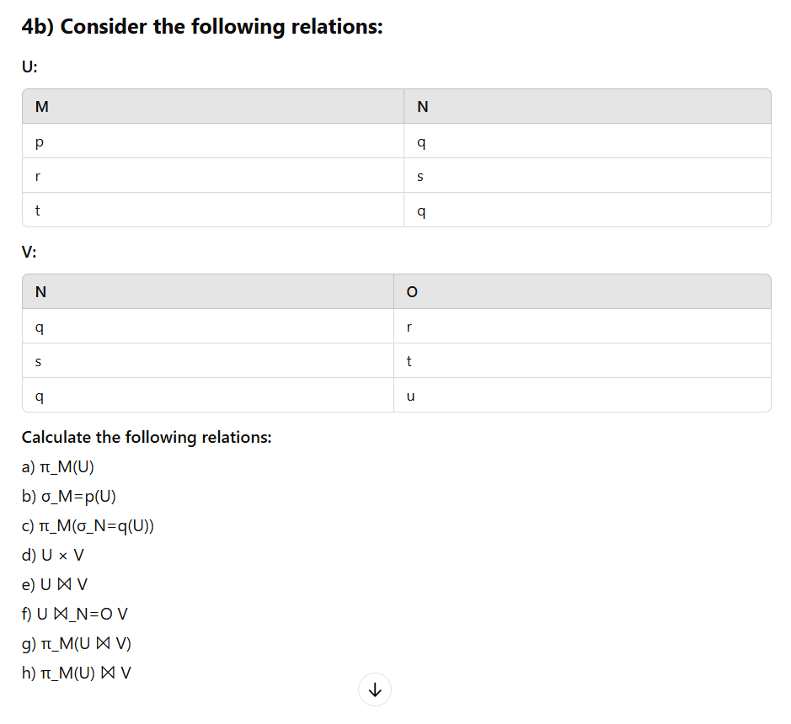

📑 DBMS Sorting & Query Processing — Cheatsheet

🔹 Two-Phase Multiway Merge Sort (2PMMS)
- Goal: Sort datasets too large for main memory.
- Process:
  - Phase 1 (Run generation):
    - Fill memory with up to M/B blocks.
    - Sort in-memory and write back as runs.
  - Phase 2 (Multiway merge):
    - Merge up to (M/B) - 1 runs at once (1 buffer for output).
    - Output = single sorted relation.
- I/O Cost (if 2 passes sufficient):
Total I/Os=4N(N=number of blocks)

